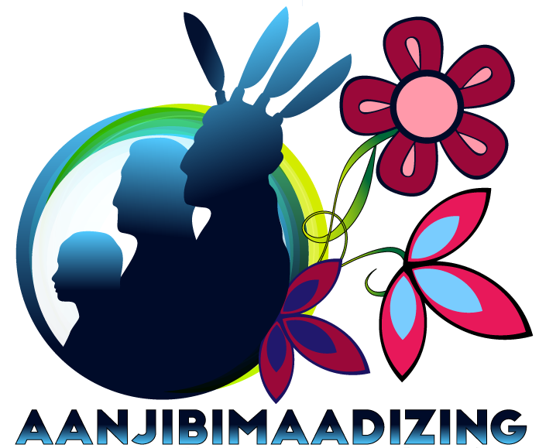

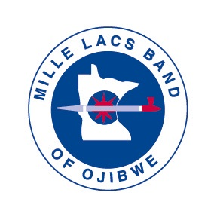

Mille Lacs Band of Ojibwe

477 Narrative Report

FY22

October 1, 2021 to September 30, 2022

43408 Oodena Drive, Onamia, MN 56359

Phone: 320-532-7407 - Toll Free: 800-922-4457 - Fax: 320-532-3785

# Table of Contents

Introduction 3

General Program Information 3

Services 3

Goals 3

Organizational Structure 4

Expansion of Programs 5

Recruitment 6

Social and Economic Conditions 7

Barriers to Employment and Unmet Needs 9

Programs 12

Fiscal Year Comparison Data 12

Budget Spent 13

Job Creation 13

Facilitated Services 13

Housing 13

Community Services 16

Child Care Assistance 16

Support Services 17

TANF 18

Welfare Assistance 18

WEX-Work Experience 18

Training and Development 19

Ojibwe Language and Culture 22

Youth Services/Ge-Niigaanizijig 23

Mille Lacs Band Suicide Prevention Project 27

Urban Office 27

FY 2022 Challenges 27

Program Outcomes 27

Conclusion 30

# Introduction

## 477 Program Description

The Mille Lacs Band 477 Program provides services to Tribal members seeking to establish self-sufficiency for themselves and their families pursuant to this plan and in accordance with P.L. 102-477, as amended. The Plan uses funds from the Department of Health and Human Services, Department of Labor, and Department of the Interior. The estimated annual allocation of the combined grant funds total is $5,098,697. The Mille Lacs Band of Ojibwe (MLBO) will authorize up to 10% of the total program funds to be utilized for economic development initiatives within the program which will be used to enhance entrepreneurial opportunities for tribal membership.

# General Program Information

## Services

The program has adopted a culturally appropriate name, Aanjibimaadizing, which translates as “changing lives”. Aanjibimaadizing is operated as a division of the MLBO Department of Administration. The goals of the program are centered on our mission statement which is:

To assist our fellow Anishinaabe with education, training, work experiences, cultural participation, and support services to be prosperous and change their life.

The program’s goals concentrate on empowering its participants to end dependency on government assistance with an acquired purpose, or an occupation that will contribute to the well-being of their community and family. All program services are offered to support obtaining and retaining employment, improving, or creating a position of job readiness, and addressing barriers that prevent our clients from simply filling their employability development plan.

## Goals

The Mille Lacs Band of Ojibwe P.L. Law 102-477 Goals for 2022-2025 are:

1. Create youth mentorship/internship and training opportunities in all Mille Lacs Band districts that will synchronize with Anishinaabe values, for example, servant leadership to look at the well-being of people and community. This will ensure youth have a positive ongoing relationship with tribal government and promote healthy relationships with adults in the community. These opportunities will be measured by the number of youth placed in mentorships/internships and the number of youth who have completed these opportunities. The program anticipates that 50% of all youth placed will complete the internship successfully.
2. Develop Ojibwe language resources, materials, and training to be used long term with Aanjibimaadizing clients and all Mille Lacs Band members to increase the use of language, number of speakers, and improve the health and education of the community holistically. Measured by the number of books, resources, and materials available at the end of this three-year plan in comparison to current resources. Currently there is one level of Rosetta Stone. We anticipate the launch of at least one more level of Rosetta Stone in the three-year plan period.
3. Build and strengthen our training program in the following areas: outreach to potential clients, emphasis on the importance of gaining new knowledge including digital literacy, which will help in job advancement. In addition, this will help clients see the importance in self-growth, by growing their skills. This will be measured by the number of clients attending trainings or the number of clients gaining employment, thus advancing their careers.
4. Increase indigenous business development of individuals and companies by promoting skills to build human capital, business plans/development and problem solving. Measured by the number people attending small business classes and number of people obtaining a small business development grant.

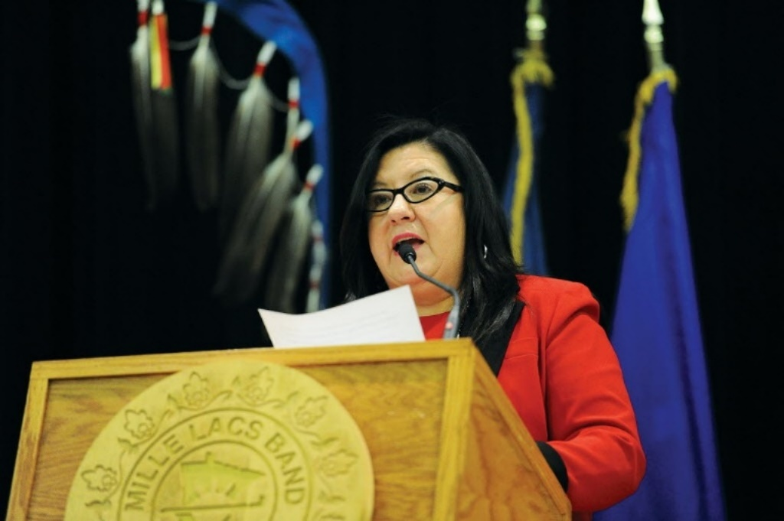The program goals align with the Mille Lacs Band of Ojibwe goals. The Band’s Chief Executive issued a directive at the State of the Band in January 2022 to first stream-line policies and procedures and secondly to improve relationships with Band members with a focus on enhancing customer service skills. The Commissioner of Administration also directed the Aanjibimaadizing program to create “youth mentorship and training opportunities” to develop workforce skills in the Mille Lacs Band youth.

The Chief Executive, as well as community surveys, has identified that Ojibwe language revitalization efforts are integral to sustaining our way of life and our inherent rights as a sovereign nation. Culturally relevant practices, teachings and trainings will be provided to clients. The elders have determined that language revitalization is the key to self-sufficiency and our well-being.

*Mille Lacs Band of Ojibwe Chief Executive Melanie Benjamin*

Other goals identified are to support the small business and economic development of the rural Tribal reservation lands and increase Anishinaabe self-sufficiency. The Tribe is confident in their ability to self-determine needs.

### Client Goals

Participant goals will be tracked in the electronic data system. Outcomes will be demonstrated and reviewed on a quarterly basis. The 477 Statistical Report and anecdotal data will be used to demonstrate program effectiveness. The program would like 75% of clients to have some measure of demonstrated success at completing an outcome.

## Organizational Structure

Aanjibimaadizing is led by Executive Director Tammy Wickstrom. Ms. Wickstrom was hired in March 2019 as the Interim Executive Director. She was hired permanently as Executive Director in October 2019. There is a Director of Case Management who oversees all case managers working with clients and with TANF, a Ge-Niigaanizijig Director that oversees youth programming and activities, and a Director of Community Services who oversees facilitated programming.

*Aanjibimaadizing Staff Photo*

Aanjibimaadizing has 78 staff. Staff includes lead instructors, WEX coordinators, community service leaders, youth mentors, case managers, facilitators, Ojibwe cultural staff, intake workers, and a transporter.

Aanjibimaadizing falls under the Department of Administration in the Mille Lacs Band of Ojibwe. It has an Executive Director to provide oversight for program operations. Aanjibimaadizing provides services of Case Management, Support Services, Subsidized Employment, Education and Training, Youth Services, Child Care Assistance and TANF.

During FY19, the program began expanding these services to ensure they were available at all office locations in District I (Onamia), District II (McGregor and East Lake), District III (Hinckley and Lake Lena) and the Urban office. To increase services, the number of employees expanded from 43 in October 2019, to 52 in October 2020, to 73 staff in November 2021, and 78 staff in November 2022. Seventy percent of our employees are Native American.

*Aanjibimaadizing Organizational Chart*

## Expansion of Programs

### Supplemental Nutrition Assistance Program

Aanjibimaadizing received Merit Status and is now able to administer SNAP for Mille Lacs Band Members and First-Generation descendant households who meet eligibility guidelines in Aitkin, Benton, Chisago, Crow Wing, Kanabec, Mille Lacs, Morrison, and Pine counties. In the Urban area, the Aanjibimaadizing office can assist with a courtesy application, but final eligibility will be determined by the county of residence.

The primary goal of SNAP is to provide low-income households with additional resources for buying food. SNAP, along with other support services, also serves as an automatic stabilizer for the economy. This impact “multiplies” throughout the economy. For example, the businesses supplying the food and other goods—and their employees—have additional funds to make purchases and hire more staff. This multiplier effect on the economy may extend well beyond the initial money provided to SNAP participants. It is estimated that on the Mille Lacs Reservation, for every $1 of SNAP support issued, it adds $9 to the local economy. *(Quantifying the Impact of SNAP Benefits on the U.S. Economy and Jobs, 2019)*

### Child Care

When CCDF was pulled under the umbrella of P.L. 102-477, this allowed the program to expand childcare into District 2 and District 3. The childcare services are provided as ‘before’ and ‘after’ care to the Tribal Head Start/Early Head Start services. P.L. 102-477 funding paid for staff working with Mille Lacs Early Education to support programming and the provision of childcare.

### Youth

January 1, 2020, the MLBO Education department’s youth program Niigaan combined with the Aanjibimaadizing’s youth program, Wiidoo. The new name of this programming is Ge-niigaanizijig. This allows for cost sharing between Tribal funds and P.L. 102-477 funding. It benefits both programs with cost sharing for supervision, transportation, supplies, and food. It benefits children and families by providing consistency in programming and operations. The Director of the Youth Services falls under the Executive Director of Aanjibimaadizing. Lesson planning aligns with the four pillars of the program: Ojibwe Culture, Community, Education, and Career.

### Fleet

Fleet Services for light mechanic work is another area of expansion for the program. Job descriptions were created for a Fleet Manager and a Mechanic. Both positions are filled as of October 2021. This has become a training program for clients to learn mechanical skills that lead to employment. Automotive Technician employment is a high demand field in our service area. This work experience can be done in conjunction with taking Auto Technician classes from Pine Technical Community College, who the department has had a successful three-year partnership. The department is providing a service for MLB department vehicles and can charge for those services. Renovation of an MLB-owned space into a light mechanic garage with one (1) lift was complete in February 2022.

### Wraparound Merger

The Wraparound program merged with Aanjibimaadizing on September 1, 2020, allowing the program to support clients with more intensive barriers to finding employment including housing, addiction, re-entry from prison or jail, and transportation.

### New Facility

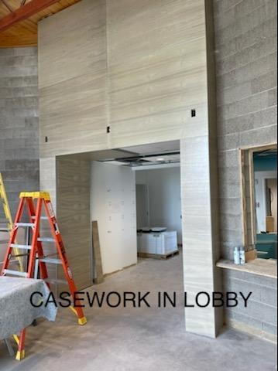In FY20, the Mille Lacs Band of Ojibwe built a new state-of-the-art clinic in District 1. The former clinic building on Migizi Drive was gifted to Aanjibimaadizing. The program has moved into this building as of October, 2020. All District 1 staff and services are located within this building except for a facilitator who has an office by the housing units on Ookwemin Loop.

*Lobby Entrance*

This facility allows staff to have separate offices, practice social distancing and have more space to provide services. The building will need major renovations to provide additional client services and training. Here is a list of planned improvements:

1. Upgrade the heating and cooling system.
2. Painting inside and out.
3. Plant a large garden for client use.
4. Create a commercial kitchen to teach cooking and restaurant service skills. This can be used to serve local events as well.
5. A picture containing wall, indoor, basement, dirty

   Description automatically generatedCreate an Ojibwe Language and Culture classroom. This will provide space for language instruction and making cultural crafts that clients can keep or sell.

*Staff Flex Space*

1. Develop a space for a gift shop. Clients can make items to sell for income and learn retail skills.
2. Classroom spaces for ongoing training.
3. A recording booth has been installed to work with Rosetta Stone and language recordings.
4. A dedicated youth space for meetings and events.
5. One-stop shop for many services that clients need.

Aanjibimaadizing is excited about the renovation and the potential to provide more services in the community that will build client skills. The renovation is expected to be complete in June 2023.

## Recruitment

Aanjibimaadizing has offices in the Urban area, District I, District II and District III. Youth Services are provided in District I, District II, District IIa, and District III. The offices are open to walk-in clients. Clients can also call or email. Aanjibimaadizing has information on the MLBO website and an informational Facebook account. Other MLBO departments make referrals to the program on a daily basis.

### Eligibility

To be eligible for 477 services, an applicant must meet at minimum the five (5) eligibility criteria:

* A signed and dated application
* Proof of residency in the service area
* Tribal Membership
* Selective Service Registration for males over the age of 18
* Employability Development Plan (EDP) that is signed and dated

Other components of the program may need additional documentation, including income. Those requirements will be spelled out in the policies and procedures. Aanjibimaadizing will serve a majority of low-income participants.

Currently, the Mille Lacs Band of Ojibwe has nearly 4,800 Band members. Approximately 44% of band members live off the reservation, while the remaining 56% live on the reservation in the various Mille Lacs Band districts. The Mille Lacs Band of Ojibwe Reservation is comprised of four small communities in central Minnesota: District I – Mille Lacs (Mille Lacs County), which is 12 miles North of Onamia. District II – East Lake (Aitkin County), which is located 3 miles South of McGregor. District IIa (Mille Lacs County), which is located just outside of Isle. District III – Lake Lena (Pine County), which is located 30 miles East of Hinckley. There are significant amounts of MLBO members living in Hinckley and the Minneapolis/St. Paul area. In FY21, approval was given to serve MLBO members, descendants, and other federally recognized tribal members in Chisago and Kanabec counties.

##### Service Area for the Program 477 Plan

**Aanjibimaadizing’s service area includes the counties of:**

**Aitkin Anoka**

**Benton Chisago**

**Crow Wing Hennepin**

**Kanabec Mille Lacs**

**Morrison Pine**

**Ramsey**

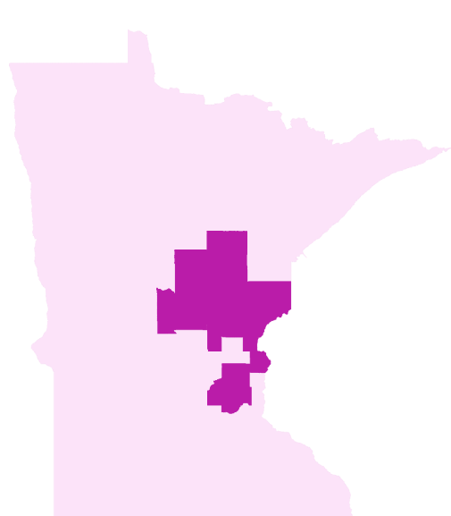

The Mille Lacs Band is one of six members of the Minnesota Chippewa Tribe, which was formed in 1934, during the Indian Reorganization Act. The other Bands that make up the Minnesota Chippewa Tribe are White Earth, Leech Lake, Bois Forte, Fond du Lac and Grand Portage.

#### Graphical user interface, website Description automatically generatedWebsite

To better disseminate program information and trainings to our clients, Aanjibimaadizing has developed a training and resource website at www.aanji.org. Continually a work in progress, this website is maintained by the Instructional Team where clients will be able to access online courses they have developed and online learning tools. Online applications for Aanjibimaadizing and the programs it offers can be found there as well. Please visit www.aanji.org.

#### Facebook

During COVID-19, Aanjibimaadizing used Facebook as a main source to communicate with clients and the community. Through FY21, the number of people following our page increased to 957. At the end of FY22, it had a following of 1,845 people and 1,558 likes.

## Social and Economic Conditions

### District I and District IIa

Aanjibimaadizing’s main office is located on the reservation, north of Onamia in Mille Lacs County. The recruitment area is a 60-mile radius from the District I reservation including the counties of Aitkin, Benton, Crow Wing, Mille Lacs, and Morrison counties. This area includes District IIa (Isle).

According to 2021 Census data, Mille Lacs County has a total population of 26,867. Out of the total population, 6% are under the age of five (5) and 5.7% are American Indian. 9.2% of the total population is living in poverty. The median income is $57,173. The high school graduation rate is 89.2%. According to the Minnesota Employment and Economic Development statistics as of October 2022, the Mille Lacs County unemployment rate was 1.7%. The U.S. Bureau of Labor Statistics lists the national unemployment rate as 3.7% and the Minnesota unemployment rate as 1.7%.

The Mille Lacs Reservation unemployment rate is12.3% based on US census data from 2020. This data includes all Reservation land areas in all districts. The program believes this unemployment rate may be higher and will be working with Mille Lacs Early Education and the MLBO grants department to gather additional data.

### District II

Aanjibimaadizing has another location in the town of McGregor in Aitkin County. The recruitment area is a 30- mile radius, including most of Aitkin County.

According to 2021 Census data, Aitkin County has a total population of 15,887. Out of the total population, 3.7% are under the age of five (5) and 2.5% are American Indian. 11.1% of the total population is living in poverty. The median income is $49,086. The high school graduation rate is 91.9%. According to the Minnesota Employment and Economic Development statistics as of October 2022, the Aitkin County unemployment rate was 2.4%.

### District III

Aanjibimaadizing also operates out of the Aazhoomog area, east of Hinckley in Pine County. The recruitment area is a 30-mile radius from the reservation and includes Pine County. Services for youth are provided in Hinckley at the Meshakwad Community Center. Services are not provided for Wisconsin residents.

According to 2021 Census data, Pine County has a total population of 29,302. Out of the total population, 4.5% are under the age of five (5) and 3.5% are American Indian. 10.2% of the total population is living in poverty. The median income is $55,606. The high school graduation rate is 90.1%. According to the Minnesota Employment and Economic Development statistics as of April 2016, the Pine County unemployment rate was 2.4%.

### Urban Office

Aanjibimaadizing has a site office in downtown Minneapolis to service the Mille Lacs Band members and American Indian population in the Minneapolis/St. Paul, or Urban area. This includes the counties of Anoka, Hennepin, and Ramsey. The office is located on Franklin Avenue in Minneapolis in the neighborhood that focuses on American Indian services.

### Unemployment Rates

Much of the Mille Lacs Band Reservation lies within Mille Lacs County, and the foregoing chart indicates the huge disparity in employment opportunities that exist between the Reservation economy and the surrounding regional economy in our service area. As soon as one crosses the boundary on the Reservation, unemployment rates increase as much as 6 times as the surrounding counties.

*From 2016-2020 American Community Survey, U.S. Census Bureau

### Economic Activities

The Mille Lacs Band of Ojibwe and its businesses are a major employer in Mille Lacs and Pine counties. There are several small businesses, educational jobs, medical field positions, county jobs, and seasonal tourist positions in all northern service counties. The Urban office has small businesses, large corporations, educational jobs, medical field positions, county jobs and several service companies focused on the American Indian community.

In the past year, the program has been promoting small business development. An online class has been held every Tuesday to assist people in developing a small business plan. We have partnered with Mille Lacs Corporate Ventures and the Initiative Foundations Enterprise Academy, which is focused on small business development. Clients who had a 25% match and had created a successful small business plan were eligible for a $5,000 grant. Aanjibimaadizing awarded over 21 grants which led to employment opportunities for 50 people.

For employment opportunities internally and with employers working on MLBO projects, our TERO laws provide hiring preference to our membership. Being registered with our Program provides clients with an avenue to be job-ready and registered with our TERO Job Skills Bank.

The 2015 Amherst H. Wilder Foundation’s Minnesota Early Childhood Risk and Reach Report examined economic risks, health risks, and family stability risks in all Minnesota counties. Then each county was assigned an overall risk status. The MLBO has land in three counties: Mille Lacs, Aitkin, and Pine. Mille Lacs and Pine counties are considered high risk. Aitkin County is considered moderate to high risk.

## Barriers to Employment and Unmet Needs

### Transportation

Transportation continues to be a barrier to employment. There is no public transportation in the outstate, or rural Reservation areas. The rural reservation areas are geographically distant from employment, colleges, and many services. The urban area has a busing system, but people need to be able to afford to ride. Many Band members have less than reliable cars and/or cannot afford the expense of gas money to drive the distances to jobs or other services. In FY22, Aanjibimaadizing assisted families with car repair and auto insurance for employment purposes. Other transportation services included gas cards and limited mileage reimbursement to get to work when first employed, or to attend training. A metro bus card was provided to clients in the urban area to ride the bus. The program also pays the reinstatement fees for those working to get their license back. These services have allowed clients to travel to their jobs and to train so they can obtain and retain employment.

### Housing

Lack of housing, or affordable housing, is an issue for families and clients living on the rural reservation areas and in the Urban area. The lack of housing limits the ability to maintain stability. Homelessness on the reservation is often unreported, but a majority of clients report some type of housing insecurity. The Mille Lacs Band has continued to expand housing options, but they are not adequate for the number of tribal members living on the reservation. Many families are doubled up or living with other family members. The Mille Lacs Band has a hotel option with staggered rates in District 1, but it is at capacity and there is often a waiting list to stay there. Clients who lack stability in a place to stay often struggle to remain employed. The lack of housing close to places of employment limits the client’s abilities to retain a job, or even obtain employment.

Due to this being a significant barrier, Aanjibimaadizing worked with MLBO Housing to create Zakab Biinjina. Zakab is a supportive housing for clients to help them get back on their path to self-sufficiency. Housing is provided at limited or no cost to allow families to catch up on bills and save for a permanent housing solution. Clients living at Zakab must take financial literacy classes and we refer them to Community Development for home maintenance courses.

### Addiction

Drug overdose continues to affect the lives of many Minnesotans. In 2021, an average of four Minnesotans died each day from a drug overdose, with the total annual number of drug overdose deaths increasing 22% increase from the previous year. Moreover, for every drug overdose death, there were 10 nonfatal drug overdoses. The number of drug overdose deaths in 2021 was the highest annual number ever recorded in the state.

Many clients are struggling with chemical dependency or addiction issues. Chemical dependency affects their ability to obtain a job because many employers require a drug test prior to employment. Chemical dependency also affects their ability to obtain a job because the behaviors linked to addiction do not allow people to function well at the job and have good attendance. According to the Minnesota Department of Health, in October 2022, American Indians in Minnesota were seven times more likely to die of a drug overdose than non-natives.

Alcohol and Chemical Dependency is a significant barrier on the Reservation. Many clients are struggling with addiction themselves or in their family. Employment is affected by poor attendance, being late, high turnover rate, poor decision making, increased difficulty in completing tasks and increased disagreements. Additional support for clients dealing with addiction is needed for both staff and the clients.

### Job Market

The unemployment rate on the reservation lands is double what it is for the rest of the counties where the reservation land is located. This has only been exacerbated by COVID-19. Barriers to employment include transportation, housing, addiction, re-entry, and childcare. All of these barriers combine to further limit people's ability to obtain and retain employment in a scarce job market in rural Minnesota. The job market in rural Minnesota is limited, with the Mille Lacs Band of Ojibwe’s casinos and businesses being some of the biggest employers. For any job you get in rural Minnesota, you will need to drive and the lack of transportation for clients limits their ability to get any job that is available. While the unemployment rate is low for the state of Minnesota, the Reservation employment rate is over 7 times that of the State rate. All of the barriers and unmet needs affect employment on the reservation and with the MLBO population.

### Mental Health

Clients often have mental health issues that affect their ability to retain a job. These issues are frequently unidentified. Staff needs support in working with clients with mental health issues. Clients need support to have overall health including mental health. MLBO has a limited number of therapists available.

### Re-Entry and Background Check

Jobs with the Mille Lacs Band of Ojibwe often require a background check. Even other businesses in the rural area also require a background check. For MLBO members with any criminal record, it is a challenge to obtain employment.

A significant number of clients are working with the program as part of probation or re-entry requirements. Aanjibimaadizing works with probation officers to ensure clients can work on their re-entry plans. We also work with MLBO departments to assist people with background check issues that may affect employment. Aanjibimaadizing needs to create a re-entry plan that can better assist clients who need multiple supports when leaving jail or prison. Clients in re-entry need a different approach and have additional needs including finding mentors, developing community, serving others, reuniting families, and finding help. Aanjibimaadizing will be working in the next year to have a cohesive plan to assist clients in re-entry to overcome obstacles and make positive choices.

### Child Care

Childcare all over the state of Minnesota is limited. In recent years, many family childcare and child care centers have gone out of business. The lack of childcare in rural areas makes it almost impossible for working families to find care for their children and maintain employment.

With area schools and other partners, Aanjibimaadizing conducted a study in July 2022 regarding childcare needs for the Mille Lacs Band Community. It concluded that there are 3,603 children, ages 5 and younger, living within the Mille Lacs Band of Ojibwe 3-county service area who are eligible for childcare services. This 3-county service area only has about 800 licensed childcare slots for these 3,603 children. This includes the 180 slots at the three Head Start/Early Head Start/Childcare sites licensed by the Mille Lacs Band of Ojibwe focusing on children enrolled in Federally recognized tribes.

Childcare is a significant financial burden. The average cost for an infant in Family Childcare is $150/week totaling $7,800 each year. The average cost for an infant in a Childcare Center is $250/week totaling $13,000 each year. The average median household income in the 3-county service area is $52,970 a year. For a two-parent, two-child family in Mille Lacs County, it costs approximately $86,952 to secure a modest, yet adequate, standard of living. The expense of childcare in the urban area makes it a challenge for people with young families to retain a job, with childcare for an infant costing up to $17,000 a year. It is very expensive for both the provider and the family and can easily amount to more than 25% of a family’s income - more than any of their other expenses.

The Final Community Survey Analysis results were:

From the Parent Survey -

* 25% indicated they do not use childcare because it is too expensive, or it does not exist.
* 17% drive between 11 & 30 miles to their childcare site with another 17% driving over 30 miles.
* 25% need childcare for over 35 hours per week.

From the Childcare Provider Survey -

* Infant and toddler slots have the largest waiting list.
* The biggest challenges childcare providers face is low pay and limited ability for time off.

From the Employer Survey -

* 54% indicated that unavailable childcare has caused employees to be absent from work.
* The biggest challenge employers face is keeping a consistent workforce due to staff shortages and staff turnover.

### Staff

Almost four years ago, Aanjibimaadizing hired an Executive Director with over 12 years of leadership experience in grant management. Aanjibimaadizing is developing a training program to assist Case Managers and Youth Staff. Over the last year, the documentation for client services and work participation rate (WPR) has improved again. Staff turnover has decreased with several staff maintaining their positions for over two years. The program is continuing to make significant improvements in this area.

### COVID-19

The global pandemic of COVID-19 has significantly impacted program operations. All MLBO government offices were open by appointment only from mid-March to summer 2020. In summer 2020, governmental operations and Aanjibimaadizing offices started moving back to normal operations. When fall 2020 started, the number of COVID-19 cases in reservation communities and counties started skyrocketing. This led to the closing of MLBO government offices and Aanjibimaadizing in November 2020 with Offices reopening in February 2021.

##### Pandemic Unemployment Rates

|  |  |  |  |  |  |
| --- | --- | --- | --- | --- | --- |
|  | October 2019 | May 2020 | April 2020 | June 2021 | May 2022 |
| State of MN | 3.9% | 9.4% | 8.6% | 4.4% | 1.6% |
| Mille Lacs County | 4.7% | 10.9% | 11.4% | 4.9% | 2.2% |
| Pine County | 4.2% | 11.9% | 12.1% | 4.7% | 2.4% |
| Aitkin County | 4.3% | 10.9% | 11.4% | 4.5% | 2.6% |
| Hennepin County | 4.5% | 10.3% | 9% | 4.8% | 1.6% |

The state unemployment rate reached a high of 9.4% in May 2020 and is currently 1.7%. Data for the counties with the highest numbers of Mille Lacs Band members are listed above. Unemployment rates in these counties are higher than the state and even higher on the actual reservation, which does not have specific data collection related to unemployment for those areas. However, 2016-2020 Census Bureau data has the MLBO reservation unemployment data at a minimum of 12.3%. Since unemployment rates rose throughout the counties and state in a uniform pattern, we can assume that the unemployment rate on the MLBO reservation rose above 14%.

Throughout the challenges of COVID-19, Aanjibimaadizing has continued to provide services to all clients utilizing a variety of virtual platforms; including Zoom and online applications developed with Laserfiche. Aanjibimaadizing has been fully open to the public since Spring 2022. However, the pandemic effects are still in place including illness outbreaks, increased unemployment levels on the reservation and limited contact with outside partnerships. There have been positives to come out of the pandemic as well including the ability of staff to work remotely, online applications were created, a digital billing and payment system was installed, website developed, and increasing our outreach digitally. Throughout the pandemic, Aanjibimaadizing increased the number of clients served, created jobs, and provided training to support job skill development.

# Programs

Program data including historical data is shown below to give a clear picture of Aanjibimaadizing’s progress in meeting goals and supporting clients, both youth and adults in the program.

##### Fiscal Year Comparison Data

|  |  |  |  |  |  |  |  |
| --- | --- | --- | --- | --- | --- | --- | --- |
|  | Cash Assistance Clients | Total Adults | Total  Youth | Families Receiving Child Care Assistance | Children Receiving Child Care | Adult Earnings Gain | Businesses Assisted |
| FY22 | 53 | 825 | 567 | 51 | 98 | $16.55 | 116 |
| FY21 | 56 | 736 | 406 | 39 | 72 | $12.75 | 126 |
| FY20 | 70 | 600 | 350 | 47 | 79 | $11.36 | 71 |
| FY19 | 85 | 668 | 258 | 19 | 32 | $7.14 | 64 |
| FY18* | 42 | 307 | 180 | 2 | 2 | $6.63 | 24 |
| FY17 | 33 | 182 | 111 | 28 | 43 | $2.00 | 134 |
| FY16* | 18 | 352 | 379 | 28 | 56 | No data | No data |

*Data cannot be confirmed by the signed and submitted report. Draft reports were available for data.

##### Budget Spent

|  |  |
| --- | --- |
| Year | Amount |
| FY22 | $10,776,979.22 |
| FY21 | $7,113,052.34 |
| FY20 | $7,116,103.50 |
| FY19 | $6,472,031.00 |

FY22 had a significant increase in spending, which included carry over dollars due to the renovation of the Training Center, support for DII childcare construction, and an early education playground in DIII.

### Job Creation

A minimum of 50 jobs were created by Aanjibimaadizing related to Small Business Development. There were eight (8) Mille Lacs Band of Ojibwe Elders that were contracted to develop newspaper articles, story collection, and support resource development. Fifty jobs were created by Rosetta Stone to develop materials.

Job creation for small business support, elder content development and Rosetta Stone totals 108.

## Facilitated Services

On September 1, 2020, the Wraparound Department merged into Aanjibimaadizing programming. Wraparound Facilitators and Aanjibimaadizing Case Managers were serving the same clients and often duplicating efforts to assist them in overcoming barriers. With the Case Managers having large caseloads, using the Facilitators to give intensive support to clients who needed more time made sense. This merger decreases application process for clients and provides support for clients that meet the Aanjibimaadizing mission and goals.

Aanjibimaadizing offers facilitated services to help connect clients to other support services within the community. Case Managers may refer clients to Facilitators to assist them in meeting their goals to obtain and retain employment. Often these services support client needs that are social, health, and mental health related. Facilitated services offer a more targeted support for employment, training, and self-sufficiency.

There are currently 65 clients and families receiving facilitated services. There are 28 occupied housing units within Zakab.

### Housing

#### Zakab Biinjina

During FY21, Aanjibimaadizing began working with Community Development and Mille Lacs Band Housing Department (MLBHD) to have Aanjibimaadizing oversee housing units in Wahkon, Hinckley and District 1 on Ookwemin Loop. This housing would be provided to clients experiencing homelessness. Clients would be required to work their case plan successfully for three (3) months prior to moving into their unit. All housing would be considered safe and sober. Priority would be given to families. This would be considered a supportive service. Lack of stable housing is a barrier for many clients and impedes their ability to be successful at employment. This became operational in FY21.

#### Housing Grants

When Aanjibimaadizing merged with Wraparound, several housing grants became available to the program to assist clients and community members. This aligns with Aanjibimaadizing’s holistic approach to client services. Lack of housing impacts client abilities to maintain employment.

##### Preventing and Ending Homelessness

In 2013, Minnesota adopted its Plan to Prevent and End Homelessness, which incorporated strategies and actions with the goal of ending chronic, veteran, and family and youth homelessness. Effectively ending homelessness means preventing homelessness whenever possible and if homelessness does occur, that it is rare, brief, and nonrecurring (one-time). The outcomes of FHPAP, which align with the state plan, are to:

* Reduce the number of people who become homeless for the first time (Prevent)
* Reduce the number of people who experience homelessness (Rare)
* Reduce the length of time people experience homelessness (Brief)
* Reduce the number of people who return to homelessness (One-time)
* Increase equitable outcomes for households who are disparately impacted by homelessness (Equity)

As a temporary and short-term support program, FHPAP is not ‘welfare’ nor an entitlement program. FHPAP is a program that targets people who are currently homeless or at-risk of homelessness and could find and maintain their housing with minimal help*.* The flexibility of FHPAP funds complement and leverage other area services and fill gaps in the homeless response system. Twenty-nine (29) families used the funds to prevent homelessness. Nine (9) families were Rapidly Housed.

Minnesota Housing has awarded, in collaboration with the Minnesota Tribal Collaboration, the Mille Lacs Band with $90,000 for 10-01-2022 to 09-30-2023 grant year. Our goal is to prevent 36 families from becoming homeless and to assist 35 people finding permanent housing.

##### Family Homeless Prevention Assistance Program (FHPAP)

The Family Homeless Prevention and Assistance Program (FHPAP) was established in 1993 by the Minnesota Legislature to assist families with children, single adults and youth who are homeless or at imminent risk of homelessness. In 2016, the Minnesota Legislature amended FHPAP statute to include tribal governments as eligible FHPAP grantees. Minnesota Housing is the agency administrator of FHPAP funds, and funding is contingent upon approval by the Minnesota Legislature. Funds are awarded through a competitive RFP process, and current funding reaches all 87 Minnesota counties and eleven tribal nations.

##### Long Term Homeless Grant

The LTH Grant was received from the Minnesota Department of Human Services in collaboration with the Minnesota Tribal Collaboration in the amount of $151,733. The purpose of the grant is to support people who have experienced “Long Term Homelessness” meaning a lack of a permanent place to live continuous for one year or more, or at least four times in the last three years. This funding allowed Mille Lacs Band to pay for a full time Long Term Homeless Specialist. The grant funding has allowed Mille Lacs Band to integrate services to enhance housing stability for band members experiencing long term homelessness by establishing consistent resources and case management. Thirty-five (35) families have been assisted with these funds.

##### The Opioid Response – Long Term Homeless Grant

The LTH Opioid Response grant was established by the Minnesota Legislature to stabilize families with children, single adults, youth and veterans who are homeless or are at imminent risk of homelessness. Mille Lacs Band of Ojibwe in collaboration with the Minnesota Tribal Collaborative received the amount of $104,569 for 2021-2022. The purpose of the program is to support continuing innovation and development of a comprehensive system to prevent homelessness and to assist people experiencing homelessness with opioid use disorder. With the primary emphasis in prevention, the goals of the program are to:

* Assist with filling a service gap for individuals with opioid use disorder
* Prevent homelessness
* Minimize the number of days homeless
* Eliminate repeated episodes of homelessness

The grant funding allowed Mille Lacs Band of Ojibwe to pay for a full time Opioid Response Homeless Specialist. Thirty-five (35) families have been assisted with these funds.

### Pandemic Emergency Assistance Funds

Pandemic Emergency Assistance Funds (PEAF) is non-recurring short-term benefits. It may be received no more than four times and must be for different emergency situations each time. To be eligible, you must be an Aanjibimaadizing client. In total, $717,736 in funds were distributed by Aanjibimaadizing to 1,287 families. This has gone towards school expenses and winter clothing allowances as well as other needs.

#### Tribal TANF Pandemic Emergency Assistance Funds

For FY21, Mille Lacs Band of Ojibwe Aanjibimaadizing received PEAF funding to assist families impacted by the COVID-19 pandemic. Aanjibimaadizing provided services under its Aanjibimaadizing 477 Plan, for non-reoccurring short-term benefits for specific crises or episodes of need that were not intended to meet on-going needs. Assistance included, but not limited to: rent, mortgage, utilities, food, emergency housing, back to school supplies for school age children and burial assistance.

###### Annual PEAF Report as of 9/30/22

|  |  |
| --- | --- |
| Report | Funds |
| Total Federal Funds Awarded | $ 1,177,193.33 |
| Administration | $51,966.74 |
| Non-recurrent, Short-Term Benefits | $788,348.55 |

#### Other Pandemic Assistance Programs

Aanjibimaadizing has been a leader in providing COVID-19 pandemic assistance, being one of the first to distribute funds in the nation. The effective and resourceful processes of our Facilitators have been used statewide. Through this, Aanjibimaadizing has distributed over $ 4.3 million in funding. These funds directly benefited clients by allowing them to remain housed and self-sufficient.

The COVID-19 Housing Assistance Program (CHAP) distributed a total of $662,357. This program ended in FY21.

The COVID-19 Emergency Rental Assistance Program (CERA) provides direct assistance for renter Households that have experienced or are at risk of financial hardship due to the COVID-19 pandemic. This assistance is meant to help prevent homelessness and maintain housing stability. The Program is funded through the federal Emergency Rental Assistance (ERA) program. $2,965,319 in funds have been distributed by Aanjibimaadizing to 2,197 households. This program ended the summer of 2022.

The HOMEOWNER’S Assistance Fund is federal funding that can provide full or partial payment assistance to eligible homeowners unable to make full delinquent mortgage payments and provide funds to resolve delinquent payments for utility services, excluding phone and internet, due to a continuing financial hardship associated with the Coronavirus pandemic. As of October 1, 2022, $685,391 had been distributed to 486 applicants. This program is currently distributing funds.

###### Pandemic Assistance Fund Totals

### Community Services

Aanjibimaadizing has Community Service Crews in all reservation districts that provide lawn mowing, yard maintenance, limited outdoor home maintenance and walkway snow removal for all Elders living in one of the Reservation Districts. The crew leaders supervise WEX workers and support work readiness skills for clients.

|  |  |  |  |  |
| --- | --- | --- | --- | --- |
|  | District I | District II & IIa | District III-Hinckley | District III- Lake Lena |
| Elder Homes Served | 58 | 50 | 45 | 28 |

## Child Care Assistance

Aanjibimaadizing provides childcare assistance to TANF clients and other clients to help pay for childcare to retain their jobs. Childcare assistance has recently been approved with the new 477 plan for Urban area Band members.

|  |  |  |  |  |  |
| --- | --- | --- | --- | --- | --- |
|  | District I | District IIa | District II | District III | Increase from FY21 |
| Number of Children | 74 | 1 | 9 | 14 | 31% |
| Number of Families | 38 | 1 | 5 | 7 | 36% |

During FY22, Child Care assistance in the amount $161,561 was provided to 51 families and 98 children.

### Child Care Development Fund (CCDF) Quality Improvements

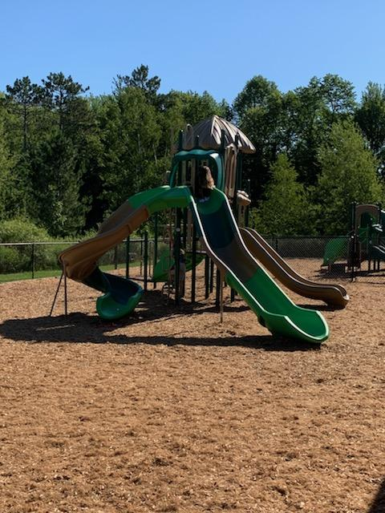The Child Care Development Fund (CCDF) provides quality support for safety concerns such as COVID-19 cleaning supplies, safety for childcare, and playground equipment. Aanjibimaadizing manages the CCDF for Mille Lacs Band of Ojibwe (MLBO).

Aanjibimaadizing works in partnership with MLBO Education Department to administer childcare support by providing funding to support staff for childcare in all districts and coordinates with Mille Lacs Early Education to help with childcare assistance applications for services.

The Executive Director of Aanjibimaadizing assisted and mentored the Mille Lacs Early Education Director for several months starting in April 2022.

## Support Services

Aanjibimaadizing offers supportive services for clients that include:

* vehicle and tire repair
* vehicle insurance
* clothing support for newly employed and WEX clients
* gas support for newly employed and WEX clients

The program also provides support for training that will help people obtain or retain employment. Support Services are a large part of the total services provided. In FY22, $908,928.43 in support services was distributed to adults.

### TANF

TANF provides monetary support for families with children under 18. To receive TANF support, families must provide documentation that they are working, looking for work, getting training or education, or completing other activities that lead to self-sufficiency. This documentation is compiled into a yearly Work Participation Rate (WPR). TANF has a 60-month lifetime limit, meaning that a client cannot receive TANF funds for longer than 60 months in their lifetime. Many families in the Reservation service area use the full 60 months. The TANF client rate has been stable and fairly low in the last three years. There are currently 54 TANF participants. Clients may choose to receive TANF from the Tribe or from the County.

TANF had a large challenge in clients reporting hours. Many TANF clients lost their job or had reduced hours due to COVID-19. Aanjibimaadizing responded to this challenge by looking at other ways families could support themselves and their family stability during the pandemic. Many parents had to become teachers and work actively with their children on homework. The Program has worked hard to increase work participation hours and reporting for all clients. This is evidenced in the data listed below.

##### Work Participation Rate

|  |  |
| --- | --- |
| FY22 | Tentative rate is 35% |
| FY21 | Tentative rate is 60% |
| FY20 | 59% |
| FY19 | 35% |
| FY18 | 7.6% |
| FY17 | 26.1% |
| FY16 | 22.7% |

### 

### Welfare Assistance

Aanjibimaadizing received Welfare Assistance funding from the CARES Act. Program policies were put into place for the funding. Welfare Assistance has three (3) approved categories for the program to provide assistance to families who are post-60 months in TANF or are single adults. Welfare Assistance can be General Assistance which is a cash support, Burial Assistance for families who receive no other burial support, or Emergency Assistance for families who experience an emergency or disaster. Aanjibimaadizing is working with Self Governance to add this funding permanently to the programing. In FY22, 23 people received general assistance and nine (9) people received emergency assistance.

### WEX-Work Experience

WEX is considered a training employment to learn job skills related to current job opportunities. WEX also assists clients in gaining the soft skills needed for employment, such as attendance, being on time, getting along with co-workers, and timekeeping. WEX is training and participants are not employed by Aanjibimaadizing or their placement host. Workers who complete 720 hours in the program are eligible for a bonus.

The Aanjibimaadizing WEX offerings are designed to give participants the opportunity to test and demonstrate work readiness that supports their career plans. Each participant should have a current resume on file which they are developing through training and work experience placements. During FY22, 127 WEX Participants worked a total of 45,276 hours. This assisted local businesses by providing $447,701.47 in wages.

##### Total WEX Participants

|  |  |  |  |  |
| --- | --- | --- | --- | --- |
|  | FY2019 | FY2020 | FY2021 | FY2022 |
| District I | 15 | 31 | 57 | 40 |
| District II | 18 | 22 | 53 | 28 |
| District IIa | 4 | 7 | 11 | 5 |
| DIII | 21 | 39 | 43 | 17 |
| Urban | 36 | 49 | 77 | 37 |
| Total | **94** | **148** | **241** | **127** |

WEX plans several program improvements including but not limited to: data collection and entry, communication with work sites, expanding work sites, developing transportation to assist clients, and supporting clients to get the training they need to find jobs.

## Training and Development

Aanjibimaadizing offered multiple training and education opportunities for clients. During the past year, over 700 people have used classroom services. This included Adult Basic Education, GED assistance, resume writing, driver’s license assistance, and educational testing as well as a variety of trainings related to job security, overcoming barriers and family stability. To help protect our clients, many services and courses were offered online when possible. In FY22, Aanjibimaadizing had people attend 126 different courses. Forty-two of those were facilitated by Aanjibimaadizing, throughout all of the districts, with over 280 sessions completed. Despite the complications that the pandemic had added to providing training and development services, the number of clients we assisted continued to grow. Four hundred and forty-three people received assistance obtaining their driver’s license and 150 clients worked towards their GED.

Most people use the classroom multiple times and the support our instructors offer often requires multiple contacts on their behalf. In total, the Aanjibimaadizing Instructors completed over 4,700 contacts in FY22. On average, they work with over 18 different clients every day.

#### Adult Basic Education (ABE)

After noticing that a large segment of the client population working on their GED began the process with elementary-level reading and math scores, Aanjibimaadizing pursued a partnership to provide Adult Basic Education. We have begun the process to become a Tribal ABE Consortium, which we expect to complete within the next year. All Education and Training staff have been trained as ABE tutors. ABE can be used to assist people in advancing their literacy and math skills as well as helping them with credit recovery or earning their GED or Adult Diploma.

#### A picture containing indoor, person Description automatically generatedPine Technical and Community College

Aanjibimaadizing has partnered with Pine Technical and Community College to offer the Career Exploration & Small Business Series, Computer Basics, Business Computer Applications, QuickBooks, Parenting Piece-by-Piece, and ServSafe. Our clients were excited and eager for this opportunity, and it showed in their dedication. In FY22, 62 people received certificates through Pine Tech.

Through the two years we’ve been working with PTCC, 142 people have completed their courses. The students that attended these classes brought forth their best self, worked hard, persisted, showed up every day, and successfully completed the course work no matter how challenging it was.

##### Courses and Trainings Offered in FY22

|  |  |  |
| --- | --- | --- |
| Admin Assistant  Aanji New Hire Orientation  ACEs - Understanding NEAR Science  Acing Your Interview  Addiction Intervention  Adult Basic Education  Aging Mastery  America’s Growing Drug Overdose Crisis  American Indian Justice Conference  American Safety & Health Institute (ASHI): Child and Babysitting Safety  Automotive Technician  Behind the Wheel  Being an Ally in Indian Country  Blood Memory Documentary Screening and Discussion  BNR Narcan Training  Budget 101 and 201  Building Native Communities  Career JumpStart  Career Readiness  Career Search for Veterans  Cement Mason  Certified Nursing Assistant (CNA)  Check and Connect  Circle of Parents  COVID-19 Safety  Creating Caring Communities  Creative Job Search Online: Tools of the Job-Hunting Trade  Crisis Response Planning  Critical Connections  Dakota & Ojibwe Language  Da-nandaanookiing  Demystifying Systemic Social and Emotional Learning  Disaster Preparedness  DNR Tribal Monitor Training  Domestic Violence Support  Driver’s Education  Educational Conference for Parents & Caregivers of Children and Youth  Effect of Lateral Violence in Indigenous Communities  Emergency Medical Technician  Emergency Preparedness for the Community!  Emotional Intelligence and Making Better Decisions  Endazhi-maawanji’idiing  Enterprise Academy  Expanding the Circle  Family Friendly Earth Care  Fatherhood is Sacred/Motherhood is Sacred  Finding Balance  First Aid & CPR/Narcan/AED Training  Fitness and Hoop Dance | Gates and Gaps  GED Academy  Growing Resilient Communities  Harm Reduction in Indigenous Communities: How can we heal each other with love?  Hope for Recovery  How to take advantage of the limited Public Service Loan Forgiveness waiver  Human Trafficking Webinar Series - Preventing and Intervening in the Labor Trafficking of Students  In Our Own Voice  Inaugural Mille Lacs Tribal Economy Summit  Insights  Interview Skills Workshop  Interview with Confidence  Introduction to Apprenticeship  Keeping Us Whole: Preventing Missing and Murdered Indigenous People  Laserfiche  Lateral Violence  LGBTQ+101-  Living Well with Chronic Pain  Living Well with Diabetes  Making Cents of it All  Maternal Mortality and New Risks to Women’s Reproductive Health  Matter of Balance  Mending Broken Hearts  Mental Health Crisis Planning for Families  Mental Health First Aid  Midwest Native Fitness Training  Mind Body Medicine  Mind Body Skills  Mindful Presence: Compassionate Care for Yourself and Others  Minding your Mental Health during COVID-19 and Beyond  MLTE Summit  Money Skills  Move Mindfully  Narcan Administration  National Leadership Development Conference 2022  Native American Fitness Council: Personal Trainer  Native Language Revitalization and Native Language Immersion Curricula in Tribal Early Childhood  New Leaf  No Place Like Home  North Star Digital Literacy  Northeast Minnesota Virtual Equity Summit  Nutrition: Eating with Mental Health in Mind  Opioid Education & Narcan Training  OSHA 30  Parenting Piece by Piece  PCA  Peer-Led Innovations in Reentry Support | Prepare Yourself for Home Buying  Psychological First Aid  Question-Persuade-Refer (QPR)  Reclaiming Native Psychological Brilliance  Recovery Activism: Making Good Trouble  Recovery Coach Academy  Remembering Resilience  Resilience Conversations  Resume Writing Workshop  Safe Native American Passenger (SNAP) Car Seat Safety  Safety, Self-Care, and Sage  Serious Mental Illness and Homelessness  Serv Safe  Setting a New Priority MNCAP Poverty and Equity Conference  Sexual Assault Advocacy  Small Engine Repair  So, There's Been a Disaster  SomaYoga  Strategies to Overcome Barriers  Suicide Awareness & Prevention Workshop  Supervisor Training  Supportive Housing Learning Community and Helping with ID  Tai Ji Quan: Moving for Better Balance  The Impact of Student MH in a Pandemic  The Intersection of Race and Trauma  The Mississippi River Restoration and Resilience Initiative  Training Orientation  Transforming Youth Together  Transitions: Supporting Your Child with Mental Illness into Adulthood  Trauma Informed Care for LGBTQIA  Tribal Home Studies: The Basics and Beyond  Using family engagement approaches for recruiting and supporting foster parents and kinship caregivers  Using Indigenous knowledge to prevent and respond to disasters  Virtual Symposium: Understanding and Preventing Youth Hate Crimes and Identity-Based Bullying  Virtual Youth Town Hall: How Adults Can Help Address Challenges in the New School Year  Walk with Ease  Weaving Resilience  Wellness Series - Financial Wellness Dimension  WEX Orientation  White House Native Women Symposium  Winning Resumes  Work Essentials  Workplace Safety  Youth Mental Health First Aid  Zero Suicide Event  Zoom |

#### Tutors

In addition to Instructors, Aanjibimaadizing provided Tutors in each district to assist youth. In total, they have assisted teens recovering over 33 credits this year. Of the 57 students receiving these services, all either graduated or advanced onto the next grade.

#### Future Plans for Training and Education

* Apply to become a Tribal ABE Consortium to meet our clients’ educational needs more effectively.
* Become a third-party online knowledge testing site to offer Driver’s License knowledge exams in house.
* Continue job skills training through our collaboration with PTCC to offer quality CNA, PCA, Automotive Technician, Computer Applications, Early Childhood Education, Parenting Piece-by-Piece, ServSafe, Small Engine and Welding courses.
* Expand cultural skills, activities, and language development courses.
* Increase number of classes offered that encourage family stability and wellness.
* Continue to host Giikishkaa, a semi-annual celebration to encourage and celebrate our clients’ successes.

## Small Business Development

A small business development program was started and has become very successful. Participants who complete a business plan that meets SBA standards can receive up to $5,000 in funding with a 25% match. A weekly networking group, Endazhi-maawanji’idiing, was started to assist clients with creating a business plan and help meet business goals. Through this, $100,000 has been distributed. Twenty-one new businesses have been started which have employed no less than 50 people.

## Ojibwe Language and Culture

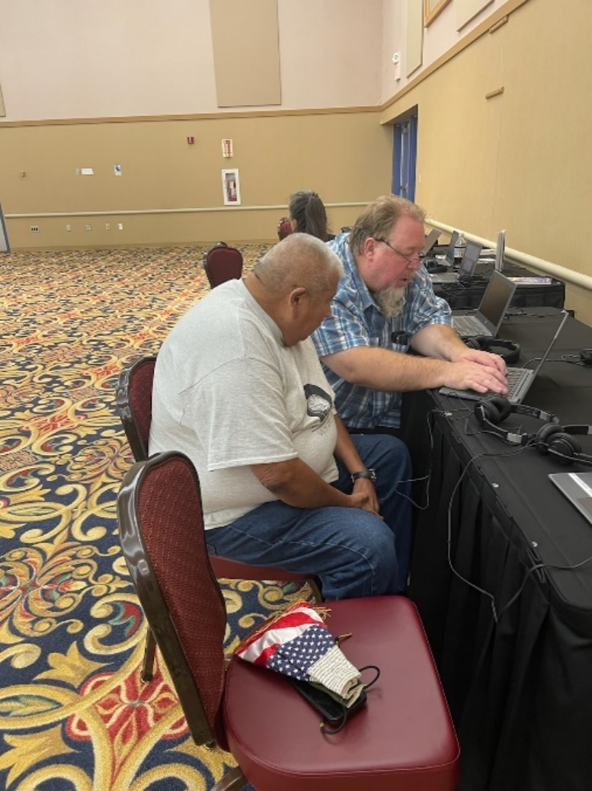Aanjibimaadizing continues to make significant increases with developing Ojibwe language and cultural resources. During FY22, significant increases were made to develop Ojibwe Language and cultural resources. An Ojibwe Coordinator was hired. He works daily with the Cultural Apprentices to teach ceremonies and improve their language skills. The program received a grant and hired a Cultural Revivalist Specialist who is working to create a digital library of Ojibwe resources.

*Assisting with Rosetta Stone Registration*

The program has a team dedicated to the establishment of long-term successful Ojibwe language instruction and cultural teachings. We are committed to Ojibwe language proficiency and creating access to the language for the benefit of all our people. Aanjibimaadizing also offers a variety of Ojibwe language and cultural classes including well-being resources such as offering tobacco, smudging, coming-of-age/puberty information for young men and ladies, and other aspects of cultural knowledge, crafts and traditional medicine. In addition to this, four videos are being created to demonstrate the history, traditions, and process of seasonal activities, preserving the skills and language used with them.

### Rosetta Stone

The first level of Rosetta Stone was released in March 2022. As of October 1, 2022, users have spent nearly 25,000 hours learning Ojibwe. The people using the Ojibwe Rosetta Stone are predominantly native, from 128 tribes across the nation (see image below) and Canada. It is being used in 28 schools.

Fifty jobs were created and $215,915 in revenue was brought in to help cover administration costs. There have been 3,438 licenses activated with approximately 4,500 purchased and waiting to be assigned.

*Indigenous people from tribes all across North America have registered for the Mille Lacs Band Ojibwe Rosetta Stone*

Rosetta Stone contracted and provided work to 25 individuals in Minnesota over the last year, including knowledgeable and technically trained Band members with audio and video backgrounds. Work on levels 2 and 3 of Rosetta Stone continues, with level 2 expected to be released in Spring of 2023.

### Ojibwe Naming Ceremonies

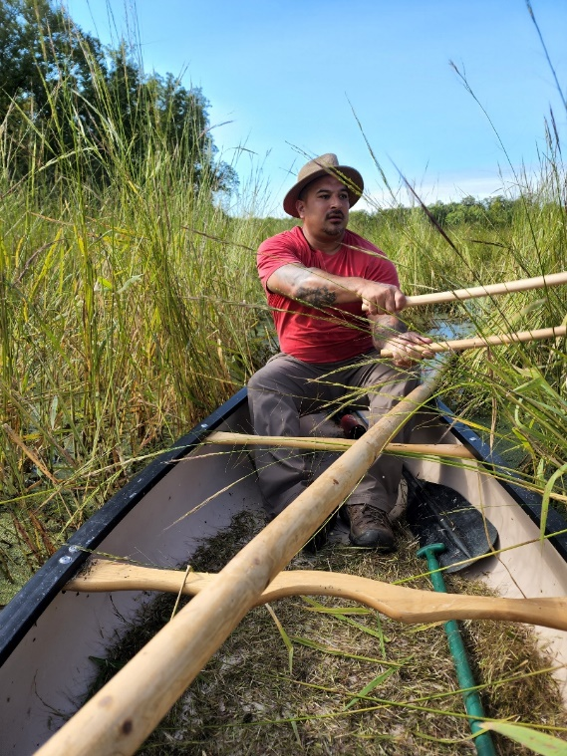During FY22, the program assisted 72 people with obtaining their Anishinaabe name. The apprentices also assist with funerals and cultural events and ceremonies, such as Midewiwin. Our goal is to help our families and youth embrace their Anishinaabe self and practice what we have been given to get spiritual support and wellness.

*Ricing*

### Resource Development

The program has continued to work with Elders virtually or in one-on-one sessions using masks and social distancing protocols. Eight elders were contracted with who provided 110 hours of audio. Eleven recordings have been developed and archived on the website. Nine articles have been published in the Innajimowin in addition to the five Ojibwemowin Books previously published.

Future plans include partnering with DNR in regard to upcoming cultural activities such as ice fishing and sugar bush. Aanjibimaadizing is also planning to develop well-being resources including but not limited to: offering tobacco, smudging, and coming of age information.

Our teams are working to save the language. Some tribes have no living fluent speakers. The MLBO is working to see that we create another generation of speakers and that our most respected population of Band members, our Elders, get to see that their work has not gone undervalued. They will soon be able to hear children speaking Ojibwe again.

*Mille Lacs Band First Language Speakers*

## Youth Services/Ge-Niigaanizijig

Ge-niigaanizijig (in the Ojibwe language means our *potential leaders*) provides programming that helps children make healthy choices that lead to self-sufficiency as adults. Services are provided to Youth ages six (6), or who have entered kindergarten, up to age twenty (20). There are currently 331 youth in the program. Over the past year, there have been a total of 384 youth that have participated. Ge-Niigaanizijig continues to enroll students. The Director of Ge-Niigaanizijig is Carlos Merrill.

|  |  |  |  |  |  |
| --- | --- | --- | --- | --- | --- |
|  | District I | District II | District IIA | District III | Urban |
| Youth Participants | 81 | 29 | 34 | 30 | N/A |
| Teen Participants | 75 | 26 | 30 | 48 | 31 |
| Current Total | **156** | **55** | **64** | **78** | **31** |

Ge-Niigaanizijig provides programming that helps children make healthy choices that lead to self-sufficiency as adults. The program has worked to streamline services with a unified approach to services. The curriculum is designed around four themes: Culture, Community, Career, and Education. The staff have been trained in a model of intervention and prevention called *Check and Connect.* This training has helped staff be empowered in their role as mentors/role models to youth and gives them insight in ways to positively intervene and support children in their education, physical activity, and social emotional development.

### Education

We have placed a high value target for our youth in regards to education. We value the accomplishments of our members during their time in school and incentivize any awards, honor rolls, and letter grade improvement that our members earn. During the 2021-22 school year, 40 youth were on the honor roll. We had 16 of our members graduate from high school. Eight of our youth started college or a trade school this year.

### Youth Facilitators

Youth Facilitators work with youth who need extra assistance overcoming barriers. Often these are education related. In FY22, Facilitators worked with 34 youth. By the end of the year, those youth had met over 100 of their weekly goals.

*DIII Youth Activity*

### Youth Support Services

Ge-niigaanizijig provides a variety of support services that help youth to reach the goals that they have set with their mentors. This includes support for driver’s education, support related to employment, musical instruments, and academic enrichment. Aanjibimaadizing provides technology to students as a support if it is not provided by their school. Through our program, 24 members have completed driver’s education. Nine youth have obtained jobs at the casino during the year.

### Career Explorations

Career Explorations is available for youth ages 16 – 24. This program functions like WEX and serves as a job training program for youth. Over the past year, there were two youth that have participated in this option. In addition, there were nine youth placed in jobs at the casino.

### Summer Internships

This summer Aanjibimaadizing held a Summer Internship that allowed teens ages 15 – 19 years old the opportunity to work along-side a career mentor currently working in a position that piqued their interest choosing from a variety of career positions within the Mille Lacs Band. Seven youth took part. The internship included career training and a community service project. Each week there was a guest speaker who would go along with the subject matter being discussed.

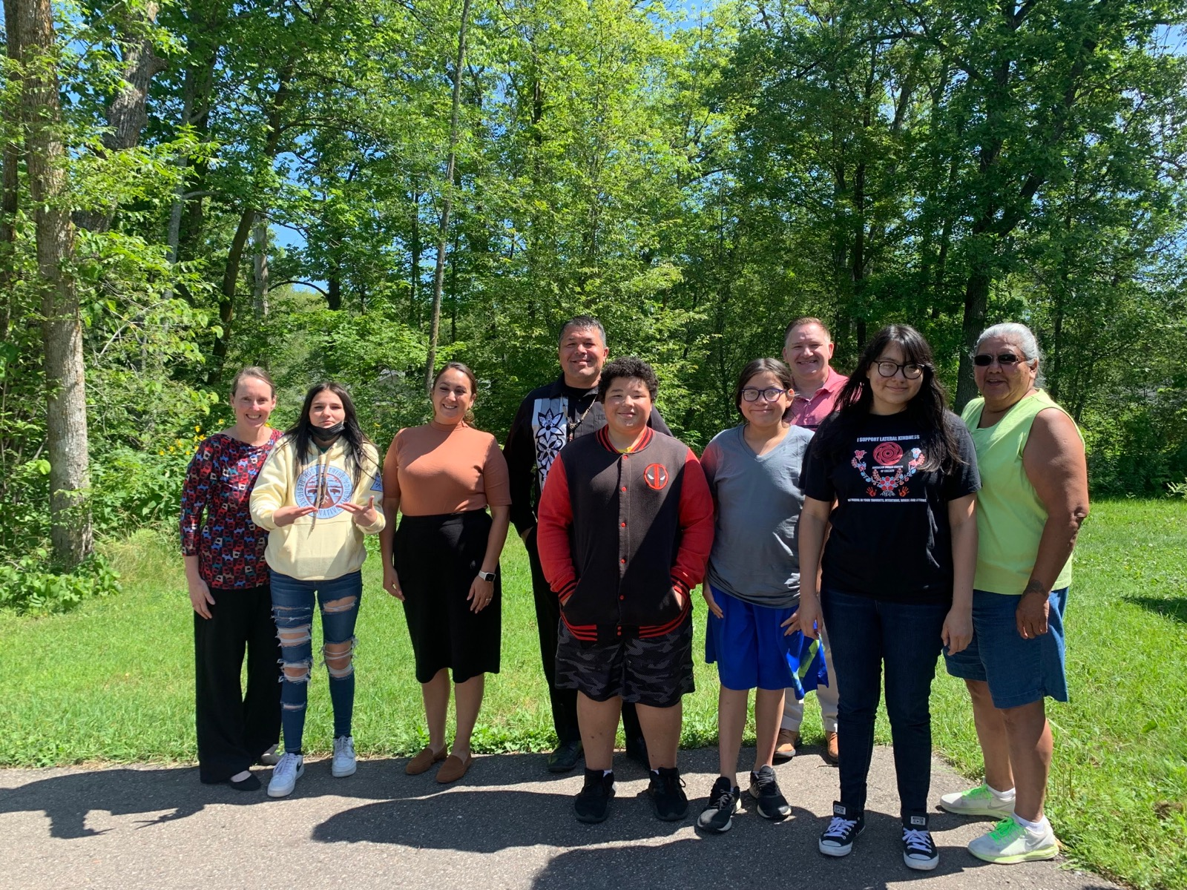Mille Lacs Corporate Ventures also has an internship program at the Casino. Twenty-seven teens took part in this program.

*Summer Internship Program with DI and DII Representatives*

### MCLV Youth Ambassadors

The Ge-Niigaanizijig program has partnered with the Mille Lacs Corporate Ventures (MLCV) program again this year to offer internships at the casinos. A total of 27 youth participated in the program, marking down another great year for this partnership. Youth were exposed to the inner workings of the casino, learned business strategy, leadership skills, and made network connections that will help them succeed in the many different business and school environments.

### Camps

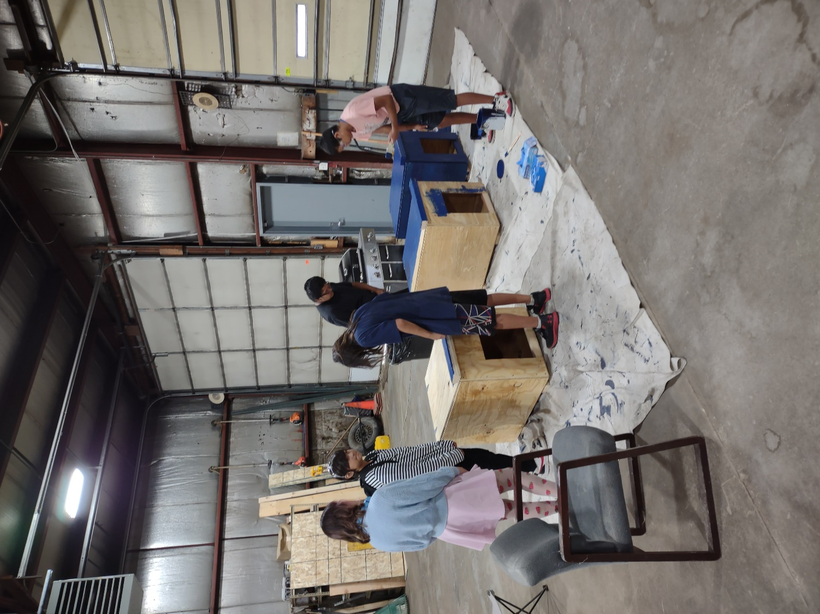Three camps were offered in FY22. Twenty-two youth attended the 21st Century Camp to learn about technology and expand their STEM skills. Ten youth discovered what it takes to be a Veterinarian at a Vet Clinic. Another five youth explored careers at a Trade Camp.

In addition to these camps, other activities include a Cooking Club which has nine youth under 12 taking part. Twenty-four youth also put on a fashion show.

### Doghouse Building

As a community service project, the youth regularly met in the program workshop to build dog houses for community members. In addition to helping the community and caring for pets, the project also teaches basic carpentry and team building skills.

While attending area Pet Clinics, band members can register to receive one. To date, 14 dog houses have been built and are keeping pets warm this winter.

### Summer Food Program

In 2022, Aanjibimaadizing once again provided the Summer Food Program in partnership with Nay Ah Shing Schools (NASS) for families. Youth could receive a hot lunch in D1, D2a and D3 for free throughout the summer. Ge-Niigaanizijig provided two staff to assist with cooking.

*Building Dog Houses*

### Ojibwemowin and Traditional teachings

One of Ge-Niigaanizijig’s goals is to include Ojibwe Language and Culture teachings into our lessons and activities. Samantha Peet from DII has led the instruction of Ojibwemowin along with assistance from James Clark. There are 110 youth participating in these classes and have been learning more each lesson. We also encourage and incentivize traditional teaching participation. In place of our group activities, our members can choose to participate in a traditional activity and receive a higher incentive pay. Traditional activities have included sugar bushing, canoe making, birch bark harvesting, sewing, beading, moccasin making, and attending powwows and ceremonial dances. One hundred nineteen youth have taken part in these activities.

### A group of people playing in a grassy fieldSports

Ge-Niigaanizijig Fitness Coordinator, Tim Taggart, worked with our members and their families throughout the summer. We offered golf, softball, kickball, basketball, and personal training. Over the course of the summer, these activities had 188 participants. A football camp was also held which had 48 participants. One hundred twenty-five youth also went to watch and support Tim at his boxing matches.

During Pow Wow weekend at Mille Lacs, we held our second annual MMIW 5k run. There were 77 participants. In FY21, there had been 28 participants.

*Golfing*

#### A group of people playing basketball Description automatically generated with medium confidenceTimberwolves/Lynx Partnership

Aanjibimaadizing has a 3-year partnership with the Minnesota Timberwolves and Lynx basketball teams. In this partnership, we offered life and basketball skill clinics with the youth attending a Timberwolves game afterward, two large basketball clinics on the reservation, internships for high school youth, and a job fair for adult clients.

The basketball clinic was held at Meshakwad Community Center and at the DI Aquatic & Fitness Center. This event was well attended. Parents and youth all had positive experiences and good things to say about their work with the Timberwolves team. The Timberwolves Camp had 120 participants in FY22. Seventy-five youth attended the Lynx game, and 240 youth attended the Timberwolves Games.

*Basketball Clinic*

#### Noah Dahlman Camp

Noah Dahlman’s mental toughness for basketball camp was offered and held at Meshakwad Community Center and the District I Community Center. Noah Dahlman is a current professional basketball player for the Lithuanian basketball team. He played his high school career at Braham High School. We had a total of 70 youth attend his basketball camp.

Ge-niigaanizijig plans several program improvements including but not limited to: data collection and entry, communication with parents and youth, lesson planning to support the four themes, and consistency across programming.

### Challenges

Most of the challenges in working with youth are related to COVID-19. Youth feel isolated and our in-person programming is limited. The pandemic has continued to affect the mental health of our participants. Some youth do not have devices to access online classes and Zoom meetings. Due to the rural nature of the reservation land, many of our youth also struggle with reliable internet access. Broadband services need to be expanded in Minnesota, especially on to the reservation.

### Youth Outcomes

New playground in Lake Lena is being built for Ge-Niigaanizijig and the community to use

Ge-Niigaanizijig expanded to Urban area and currently has 384 youth in the program

$487,552 in youth support services and activity support were distributed

77 people participated in the MMIW run

188 youth participated in Ge-Niigaanizijig sports and fitness programs

284 youth participated in clubs, camps and clinics

A youth led fashion show was held

Offered a holiday food and gift card giveaway for youth families

14 dog houses were built by youth and distributed to community members

Summer Internship program was successfully started

Nine youth are learning how to make meals in Cooking Club

40 youth were on the honor roll

16 youth graduated and eight started college

24 youth completed driver’s education and 17 received their permit

11 youth participated in Career Explorations (a job training program)

There were 27 MLCV Youth Ambassadors

Suicide Prevention training and resources were developed and shared with MLB communities, employees, and four schools

Provided opportunities for youth and Band members to attend Timberwolves games

# Mille Lacs Band Suicide Prevention Project

In the spring of 2021, Aanjibimaadizing put together a task force of Mille Lacs Band members and employees to begin organizing a Suicide Prevention Project. American Indians have the highest rate of suicide in Minnesota. Aitkin County is ranked 1st in Minnesota for the highest suicide rate of any county; Mille Lacs County ranks in the top five; Pine County is 13th. Youth ages 15-34 make up 55% of people who die by suicide among American Indians in Minnesota.

Guided by Luther C. Talks from the Minnesota Department of Health, the group has developed a Fact Sheet, Resource List, and Power Point to begin sharing within our communities. Moving forward, we will work to build suicide awareness and increase capacity with culturally specific mental health care services, support systems and guidance to ensure the whole community knows how to intervene and help. In the FY22 year Suicide Prevention information with a personal story shared from suicide survivor was presented at 5 local schools and a Suicide Prevention and Awareness Workshop was held.

# Urban Office

Aanjibimaadizing operates an office in Minneapolis to provide services to Urban Mille Lacs Band Members and other federally recognized Tribal members. During 2022, the Urban office got back to some semblance of normalcy. Our doors opened back up to the public. Community events have resumed.

Our MLBO Urban Office hosted many events this year including: 10 monthly community meetings, trunk or treat, Halloween party, children’s holiday gift distribution, Holiday party, back to school backpack and school supply distribution, Toys for Tots, American Indian Month Open House, SNAP/Secondhand Hounds Pet (vaccination, spay/neuter) clinic, CPR/First Aid/NARCAN training classes, child seat safety classes, Veteran’s Day Dinner to honor our vets, and elder lunch and bingo. We also provided rooms for our urban elders at our D1 August powwow and provided a charter bus for our urban band members to attend the MLCV Fall Feast. Summer family fun was encouraged by giving out tickets to the MN Twins games and to the MN State Fair. We also processed 328 tribal IDs and 19 hunting/fishing licenses. We are looking forward to the year ahead and hoping to do even more events to bring our community together.

*Urban Office Staff*

# FY 2022 Challenges

1. Meeting the needs of our clients with multiple issues (addiction, mental health and limited job skills) to become self-sufficient.
2. Housing for many participants is critical to stability. We have focused on providing support in multiple ways including Zakab, but this continues to be a challenge.
3. Access to other services needed is a challenge due to the remote, rural location of the majority of our offices.

# Program Outcomes

Over $1,396,480 was distributed in Support Services

Aanjibimaadizing became merit certified and is now able to administer SNAP

A community elder commented that Aanjibimaadizing was the best thing to happen to the reservation

After remodeling and hiring two staff, the Aanji Garage opened as a training & vehicle service center for MLBO Departments

Construction began on the former clinic to renovate it into the Aanjibimaadizing training center

Online applications were developed for all program services (Aanji adult and youth programming, Rosetta Stone, CHAP, CERA, CERA-HUD, HAF and PEAF)

Rosetta Stone launched with 3,438 current licenses in use by members of 128 tribal nations

110 hours of audio (oral histories) have been collected

Nine cultural articles have been published in the Innajimowin

11 elder recordings have been archived

Currently there are 437 active Adult Employment, Education and Training clients and 16 TANF clients

In total, there have been 837 adult clients this past year

127 WEX participants provided 45,276 hours of labor to the community and local businesses as they learned job skills

Facilitated services assisted with reuniting 17 families

49 families secured housing

20 families moved into permanent housing

Aanjibimaadizing distributed $4,313,067 dollars in special COVID-19 related funds since the start of the pandemic

Distributed Toys for Tots

Childcare assistance was expanded with a 36% increase in families served

Supported Mille Lacs Early Education

Supported construction at the D2 Head Start Child Care Remodel

New playground in Lake Lena is being built for Ge-Niigaanizijig and the community to use

Ge-Niigaanizijig expanded to Urban area and currently has a total of 384 youth in all of the districts

$487,552 in youth support services and activity support were distributed

77 people participated in the MMIW 5k run

188 youth participated in Ge-Niigaanizijig sports and fitness programs

284 youth participated in clubs, camps and clinics

A youth led fashion show was held

Offered a holiday food and gift card giveaway for youth families

14 dog houses were built by youth and distributed to community members

Summer Internship program was successfully started

Nine youth are learning how to make meals in Cooking Club

40 youth were on the honor roll

16 youth graduated and eight started college

24 youth completed driver’s education and 17 received their permit

11 youth participated in Career Explorations, a job training program

There were 27 MLCV Youth Ambassadors

Suicide Prevention training and resources were developed and shared with MLB communities, employees, and four schools

Provided opportunities for youth and Band members to attend Timberwolves games

Transported multiple clients to treatment

Held 2nd Annual Winter Clothing Drive

Instructors helped 725 clients with an average of 18 clients assists per day

942 clients participated in 126 different training courses offered

142 clients were assisted in earning certifications through Pine Technical and Community College

443 clients were assisted with reinstatement fees and obtaining their MN driver’s license

Expanded small business development by providing funding to more than 20 clients in FY22

## Success Stories

A couple has worked very hard trying to get employed. We also assisted with one of their Driver's License and they continue to stay sober. They are now employed full time and so thankful they have been given the chance to work.

-------

Their children are their first priority and know they are loved.

-------

We assisted an 11th grade youth that had switched over to ALC with 6.48 of 24 credits needed to graduate. They were struggling to make it to school regularly. With the transition to ALC along with weekly check-ins, weekly goals, and incentives, they have attained 7.19 additional credits and received the award of best attendance at the end of the year!

They joined our Summer Youth Internship and were able to transfer that job experience and training into three more credits for a total of 12.70 credits and is officially a senior with near perfect attendance.

-------

I see so many of our clients working hard on getting their GED. I am so proud of them and look forward to watching the opportunities it will bring them.

They keep a positive attitude and are working to find a place to call home for their family.

-------

Our youth have been working so hard at catching up from the effects of the pandemic. Attendance has improved and they are doing a great job making up credits that have been missed and graduating on time.

-------

Coming out of treatment, this individual is truly a different person and is trying very hard to be good parent and stay on the right track.

-------

A youth owes four credits - mainly due to the Covid-19 disruption. He attends ALC on Tuesdays where the School Liaison joins him. He has been working on his English credit and has the opportunity to take the final test soon for credit in that subject.

-------

I had two D2 clients come into the office to pick up resources. I told them we had a winter clothing drive and they were welcome to get items off the rack. They also picked books from the free library in the office and left with their arms full and smiles on their faces.

-------

It is so exciting to see them succeed and doing so good.

-------

They have already shown so much progress - their outlook on life is amazing!

-------

A client contacted us requesting help to get sober and get their kids back. While beginning their plan, the significant other was arrested. With another department’s assistance, we helped them enter detox. She completed detox and was taken to a treatment center. We partnered together to assist with navigating the court process by fighting for their parental rights and making a transition to bringing the children home. A plan was made for the significant other to enter treatment after their time was served. A Rule 25 was setup and placement in a treatment center was set up. They attended and completed the program. They continued to remain sober throughout this time and after. They moved in to Zakab housing. We assisted with the reinstatement of both of their driver’s licenses. Bi-weekly visits began for the family. By the end of FY22, they were completing long term trial home visits.

Also, during this, others in the family also decided to become clean.

-------

The gratitude our clients have, not just for the help we are able to offer but for everything in their lives, is so inspiring.

-------

Supporting clients through the treatment and recovery process - watching it gives hope to other family members who also enter treatment as a result.

-------

Multiple clients have moved into Zakab this year. One is working WEX while they work on getting the clearance to get a job at Grand Casino. They are also is working on their GED & Driver’s License.

-------

Helping families meet their goals so they could reunite with their children.

-------

Youth are getting accustomed to - and succeeding - with online activities.

-------

At the WEWIN conference, Mille Lacs Band participants were asked to list things that they were proud of in our community. Aanjibimaadizing, Ge-Niigaanizijig, and First Language Speakers were ranked as the top 3 of the 21 items.

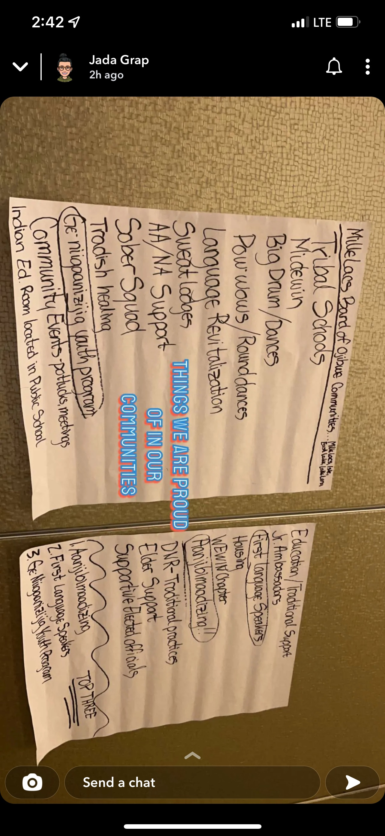

# Conclusion

In conclusion, the Aanjibimaadizing program is committed to community member success in every unique case. We have focused on what Elders have said are the most important aspects of our lives — our language and our culture. We are devoted to the work of guiding *gidinawemaaganinaanig* (*our relatives*) to a place of wellness, self-sufficiency, and an anchored identity as Anishinaabe.

